University of the Highlands and Islands, EDU
Using Blackboard course templates created by the Educational Development Unit
A step by step guide
Ann Tilbury, EDU

Contents
1. Table of figures 2
2. Table of tables 2
3. Quick note about good practice in relation to Blackboard 3
3.1. Navigation 3
3.2. Clarity and conformity 3
3.3. Accessibility 3
4. Customising the content of your Blackboard course 3
4.1. Course entry point 3
4.2. Course theme 3
4.3. Menu style 4
4.4. Default content view 4
4.5. Course banner image 5
5. Creating content areas and folders 5
5.1. Adding web links 6
6. Structuring content areas 6
6.1. Creating and editing folders in the course files area 7
6.2. Adding content to the course files area 7
6.3. Creating content in the content areas 8
6.4. Using an image file, including the activity icon images. 9
7. Using the activity icons 11
8. Finding and using images in learning resources 12
9. Additional links to resources 12

Table of figures
Figure 1 Screen capture showing menu options for text or buttons options and background and text colour 4
Figure 2 Screen capture of teaching style menu options for colours 4
Figure 3 Screen capture of content area with content icons and text 5
Figure 4 Screen capture of content area with text only option selected 5
Figure 5 Screen capture showing a web link inserted as part of the item text 6
Figure 6 Screen capture showing a web link created from the build content drop down menu 6
Figure 7 Screen capture showing EDU Resources folder in the files area 8
Figure 8 Screen capture of Leadership and Management content folders 8
Figure 9 Screen capture showing the add content area function 8
Figure 10 Screen capture showing the distorting of paragraph line spacing caused by adding an image file 9
Figure 11 Screen capture showing select the image 9
Figure 12 Screen capture showing the CSS button in the formatting bar 9
Figure 13 Screen capture showing the float left option in the CSS style menu 10
Figure 14 Screen capture of wrapped text 10
Figure 15 Another example of text distortion around an image 10
Figure 16 Screen capture showing corrected wrapped text around an image 10
Figure 17 Screen capture showing the use of activity icons within a content area 11

Table of tables

Table 1 Standard course content menu options 6
Table 2 List of activity icons with descriptions 11

Quick note about good practice in relation to Blackboard

Navigation
Aim to provide clear pathways through your content so that students know where to find things. This is particularly important in self-directed learning.

Clarity and conformity
Be specific about what you are asking your students to do – What, why, by when, how, where and who with is a good starting point as a checklist. Blackboard tools and content areas can be used in many different ways, this flexibility can be great but it can also create variations – for example where learning content is stored or how content is linked to. Aim to be consistent to ensure students can orientate themselves within the learning content.

Accessibility
Widening access for students, in this context, means providing content that is inclusive. Blackboard has built-in accessibility features, there are steps you can take to ensure the content you add is accessible. The EDU Quality Guidance for Word provides a quick guide on accessible text, bullet points, hyperlinks and symbols.

Customising the content of your Blackboard course
To begin editing, ensure that the ‘Edit Mode’ is on. This button can be found at the top right-hand corner of the screen. To customise the look of your course use the teaching styles menu. To reach the teaching styles menu click on Control panel > Customisation and then > Teaching style to reach the menu options described in the sections below.

Course entry point
The course entry point is where students will find themselves when they open the course. This can be any of the course menu options on the left-hand side. Choose an option from the drop-down menu and submit.

Course theme
Blackboard provides a range of course themes. When selecting a theme, check that there is good contrast between text and background colours. We recommend using ‘Vista’.

Menu style
The menu style text and background colour can be changed. We have used purple (to reflect the University branding). .
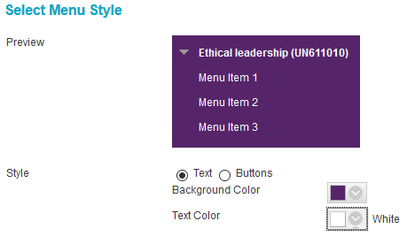
Figure 1 Screen capture showing menu options for text or buttons options and background and text colour

To select a different colour for either the background or the text, click on the drop down arrow. Select a swatch colour by choosing from the colour preview or inserting a colour value if you are looking for an exact match. The University purple is 562569
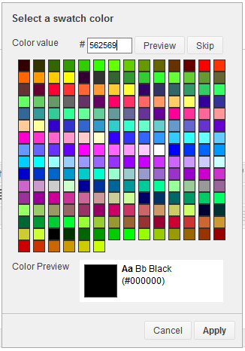
Figure 2 Screen capture of teaching style menu options for colours

Ensure that colour contrast guidelines are met to ensure text is legible on coloured backgrounds. It is advised that the Colour Contrast Checker developed by Snook is used to check colours are compliant.

Default content view
The content view is what students see in the main content area.
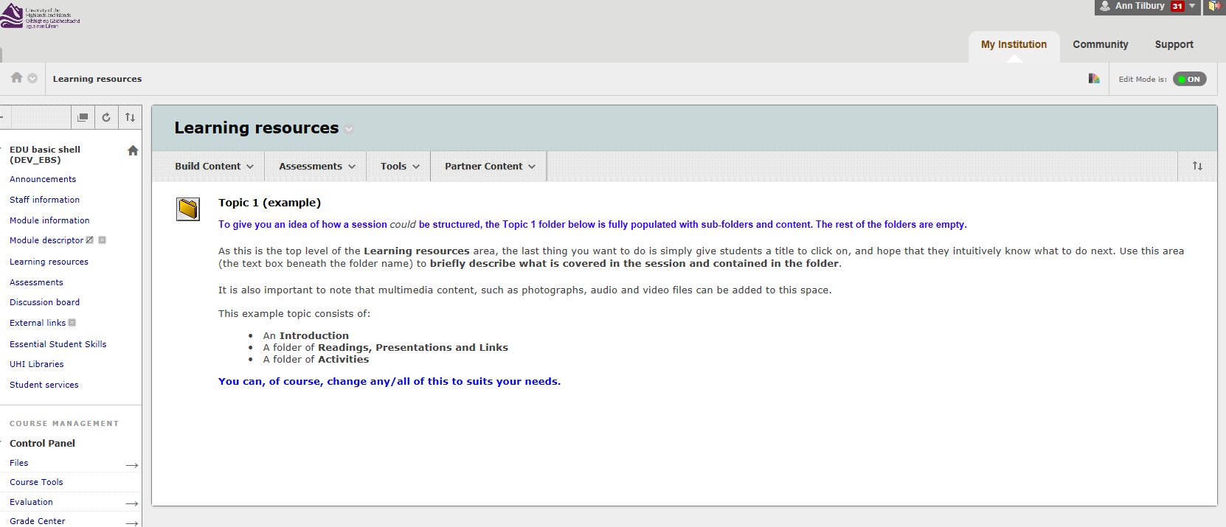
Figure 3 Screen capture of content area with content icons and text

We have chosen ‘Text only’ for a cleaner page. This removes the standard Blackboard content icons. 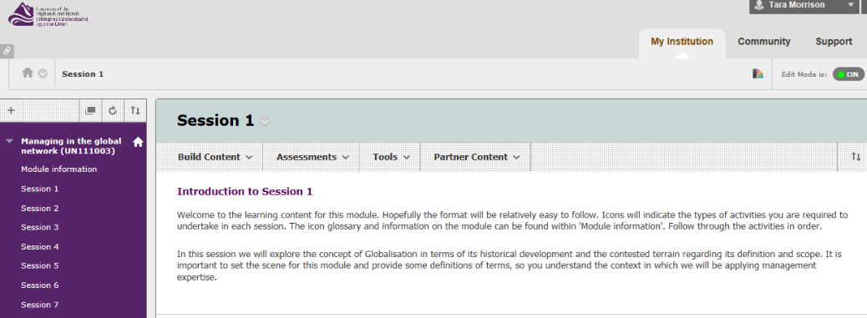
Figure 4 Screen capture of content area with text only option selected

Course banner image
A course banner image can be added to the landing page. The banner will appear on the course entry point. It can be a useful way of providing an instant brand to your course. The image files are stored in the files area and can be uploaded from there.
Note: Blackborad recommends an image size of 480 pixels across by 80 pixels high. The image is set as centred which may not suit all images.

Creating content areas and folders
Blackboard has a helpful guide to creating course areas for content. Again the way in which content is structured should ensure that students can effectively navigate through the structure to find content. You may choose a content area folder structure based on topics; weeks or other headings. Content area folders can be re-ordered, hidden or deleted. They can be web links or content areas.
Notes:
- When you are creating content the content area will not appear in the menu bar if there is no content in it

Adding web links
Within the content areas, we recommend using the ‘insert hyperlink’ in the text box as this makes the web link clearly visible as shown in Figure 5.
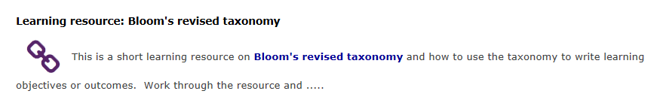
Figure 5 Screen capture showing a web link inserted as part of the item text

The result of using the web link option from the build content dropdown menu is shown in Figure 6. The web link is embedded in the title text, but it is not always obvious to the student.
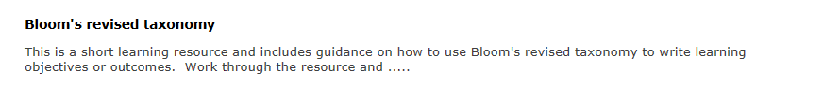
Figure 6 Screen capture showing a web link created from the build content drop down menu

Structuring content areas
The course template includes a set of standard content areas which are available from the navigation panel. Content areas can be added, renamed, hidden or deleted. The standard content areas are listed below.
Table 1 Standard course content menu options
Heading | Working with the menu options
Announcements | Click ‘Create Announcement’ (remember you can use formatting, add images, external links and internal links)
Staff information | Click on ‘Staff information > Create Contact’ and you’ll find a straightforward proforma to complete.
Module descriptor | The format of the official module descriptor might vary from course to course, but essentially, this area of Blackboard lets you give students a link (added, as it is here, as an Item) to a hard copy (either a Word document or a PDF) of the descriptor: the documents that details, amongst other things, the learning outcomes and assessments for the course.
Module information | May be hidden or may be amended to house the Student Handbook
Learning resources | This can be used as the top level of a folder structure with the topic, weekly or other folder structure within the main content area. We have used a session structure as the top level folder structure.
Assignments | You can rename this section to reflect the terms most familiar to your students – e.g. Assessments, Tasks.
Communication Tools | A range of communication tools are provided in this section including; Discussion boards; Blackboard Collaborate and Wikis. Again decide what is most appropriate for your students in helping them build a presence on Blackboard and work with their fellow students in this online environment
External links | If you would like to add an External web link to the navigation panel, simply click on the plus sign at the top of the content area and select Web Link.
UHI Libraries | Clicking on the menu item will open the University’s student Library front page in a new window.
Student services | Clicking on the menu item will open the University’s student services front page in a new window.
Essential Student Skills | Clicking on the menu item will open Essential student skills in a new window.
ePortfolio link | Here you can choose the most appropriate ePortfolio system:  Mahara  ProofPositive

Creating and editing folders in the course files area
Blackboard has a helpful guide for instructors to creating course areas for content. This gives you all the information you will need to create, edit and delete folders.

Adding content to the course files area
Once you have created the folders you require to store your learning content and related files, you can then start to add files. Again there is a very helpful guide on adding files to course files.
There is also a short video demonstration on uploading zipped packages to Blackboard provided by Murdo MacMillan. The majority of learning resources produced by the EDU are created as zipped packages. These can be found in the UHI Toolkit and can be uploaded and used in your course. There are over 350 learning resources available to staff on a wide range of topics.
The Foundation Apprenticeship course templates contain an EDU resources folder which contains a set of activity icons and the image file for the course banner.
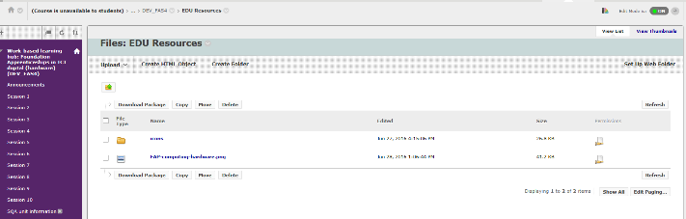
Figure 7 Screen capture showing EDU Resources folder in the files area

Creating content in the content areas
Blackboard also has a helpful guide for instructors to creating content. This includes a useful section on the types of course content you available.
Figure 8 is an example of a set of top level containers for a course.
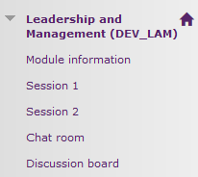
Figure 8 Screen capture of Leadership and Management content folders
When you start adding content to these containers they will appear in the navigation panel on the left of the screen, providing quick access (one click) to the learning resources for that session/week. If preferred, you can hide sessions and make them visible to students as the course proceeds.

To add a content area, click the + at the top left of the navigation panel (in edit mode) and select ‘content area’ as illustrated in Figure 9.
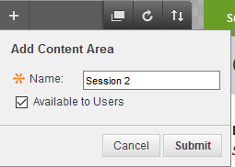
Figure 9 Screen capture showing the add content area function

Using an image file, including the activity icon images.

When you use an image in Blackboard, it will be inserted in line with the text.
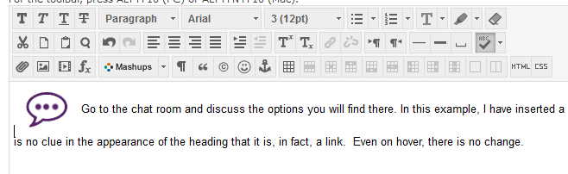
Figure 10 Screen capture showing the distorting of paragraph line spacing caused by adding an image file

In the example shown in Figure 10, you can see that this distorts the paragraph line spacing for the inline text and the line below.
To change this, select the image by right clicking on it (as shown in Figure 11)
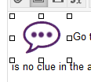
Figure 11 Screen capture showing select the image

Click on CSS on the bottom right of the formatting bar:
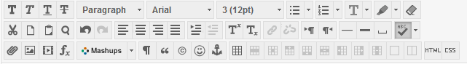
Figure 12 Screen capture showing the CSS button in the formatting bar
On the Box tab > Float select left.
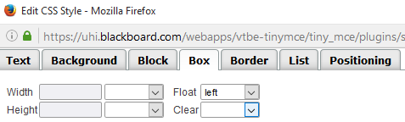
Figure 13 Screen capture showing the float left option in the CSS style menu
The text will now wrap around the image:
Figure 14 Screen capture of wrapped text

Figure 15 Another example of text distortion around an image
To display an image on the right of the page, with text wrapped to the left, again, select the image and go into CSS > box and choose right. The text will now wrap around on the left side of the image as shown in the image below.
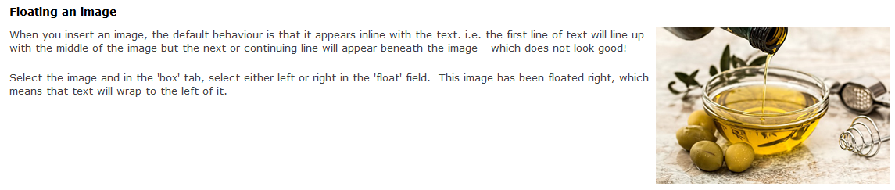
Figure 16 Screen capture showing corrected wrapped text around an image
When you add an image file to a Blackboard page you should add some ‘alternative text’ which will describe the image, for example to those using screen reading software. You will be prompted to add alternative text when you insert an image in Blackboard. In Word you should right click the image and select format and then you will be able to add alternative text (make sure you add this to the description, not the title, field.
For icons, however, our advice is to leave the alt/description field blank. We’ve tested with some screen readers and it’s best to rely on simply the activity titles for accessibility purposes, otherwise the listener using a screen reader is bombarded with duplicate information, e.g. “Chat room icon… chat room”.

Using the activity icons
A set of activity icons was agreed for the Foundation Apprenticeship courses. These were created to provide easy navigation and prompts particularly to highlight the different types of learning activities students were expected to undertake. The table below provides a list of icons and a description.

Table 2 List of activity icons with descriptions
Icon image | Icon description | Icon image | Icon description
 | Collaborate |  | Link
 | Handy hint |  | Question
 | Reading |  | Reflection
 | Research

The image below shows an example of how these can be used within the content area.
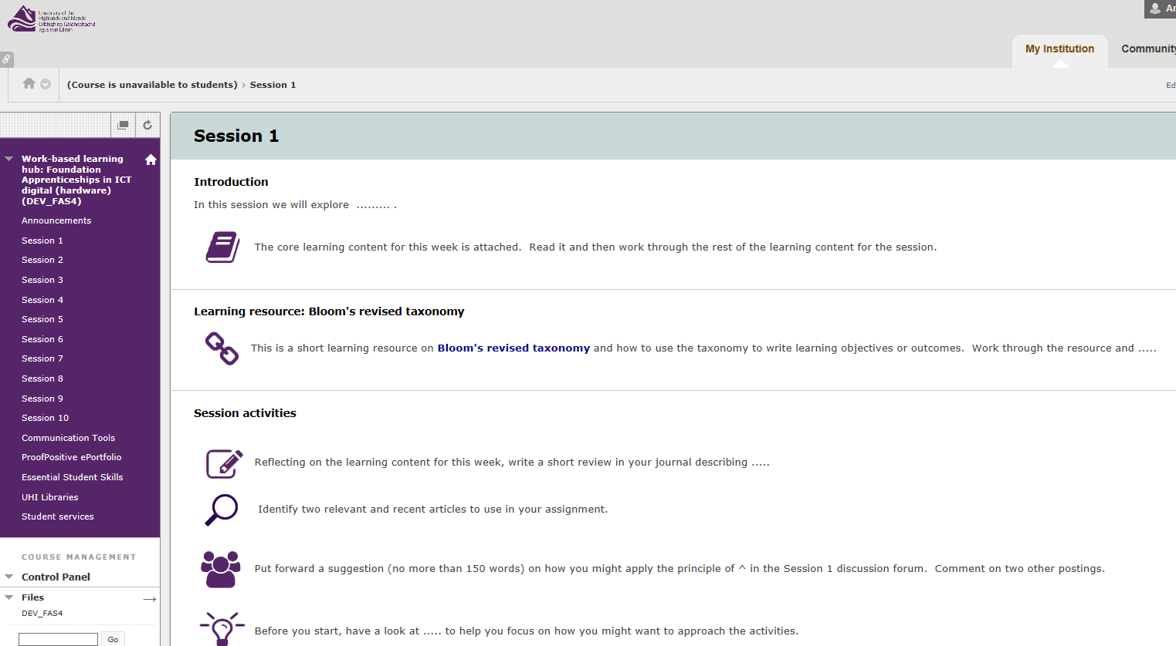
Figure 17 Screen capture showing the use of activity icons within a content area

These icons have also been included in the Word templates created for use in the Foundation Apprenticeship courses.

Finding and using images in learning resources
A guide to finding images for your learning resources has been created by the EDU. It provides useful information on copyright, examples of image banks and easy to follow steps to ensure you have used and attributed images appropriately.

Additional links to resources
There’s a wide range of Blackboard support for instructors and students. Including a series of videos - Blackboard Learn for instructors.

